|  |
| --- |
| Front End Engineering-II    Project Report  Semester-IV (Batch-2022)      Food Delivery          Supervised By: Submitted By:  Mr. Saqlain Koser Ansari Vani Verma (2210992496)  Vaibhav Mittal (2210992487)  Vanshaj Sharma (2210992500)  Tushar (2210992469)      Department of Computer Science and Engineering  Chitkara University Institute of Engineering & Technology,  Chitkara University, Punjab |

TABLE OF CONTENT

|  |  |  |
| --- | --- | --- |
| Sr. No. | Section | Page No. |
| 1. | Introduction | 3 |
| 2. | Objective And Significance | 4 |
| 3. | Problem Definition and Requirements | 6 |
| 4 | Proposed Design & Methodology | 7 |
| 5 | Technical Details | 8-9 |
| 6 | Project Overview | 10-12 |
| 7 | References | 13 |

**Introduction:**

Welcome to the world of food delivery app! An Introduction to Food Delivery Apps is like a gateway to a delicious and convenient way of ordering food. These apps revolutionize the way we dine by bringing the culinary world to our fingertips. Here's a quick overview:

* Accessibility: Food delivery apps are accessible through smartphones, making it incredibly convenient for users to order food anytime, anywhere.
* Variety: One of the most enticing aspects of these apps is the vast array of culinary choices they offer. From local favourites to international cuisines, there's something to satisfy every craving.
* Convenience: Gone are the days of waiting in long lines or struggling to make reservations. With food delivery apps, you can browse menus, place orders, and track deliveries with just a few taps on your phone.
* Customization: Many food delivery apps allow users to customize their orders according to their preferences, whether it's specifying spice levels, choosing toppings, or requesting dietary accommodations.
* Reviews and Ratings: Users can read reviews and ratings from other customers, helping them make informed decisions about where to order from and what dishes to try.
* Delivery Tracking: Once an order is placed, users can track its status in real-time, knowing exactly when to expect their delicious meal to arrive.
* Payment Options: Food delivery apps offer various payment methods, including credit/debit cards, mobile wallets, and sometimes even cash on delivery, providing flexibility for users.
* Promotions and Discounts: Many apps offer promotions, discounts, and loyalty programs, making dining out or ordering in even more affordable.
* Safety and Hygiene: Especially in the wake of the COVID-19 pandemic, food delivery apps have implemented safety measures to ensure the cleanliness and hygiene of the food and packaging, as well as contactless delivery options for added peace of mind.

Whether you're craving a comforting bowl of pasta, a sizzling plate of stir-fry, or cheesy

slice of pizza, food delivery apps have you covered. So, sit back, relax, and let the culinary adventures begin!

**Objectives**

* The primary objectives for a food delivery app typically include:
* Enhancing customer convenience by offering a seamless ordering and delivery experience.
* Increasing accessibility to a wide range of restaurants and cuisines.
* Providing timely and accurate delivery services to ensure customer satisfaction.
* Building customer loyalty through rewards programs and personalized offers.
* Optimizing operational efficiency to minimize costs and maximize profits.
* Fostering partnerships with restaurants to expand the app's offerings and reach.
* Utilizing data analytics to understand customer preferences and improve service offerings.

# **Significance**

The significance of a food delivery app lies in its ability to address various needs and challenges in the food industry:

* Convenience: Food delivery apps offer unparalleled convenience to customers by allowing them to order food from their favourite restaurants without leaving their homes or offices. This convenience factor is particularly appealing in today's fast-paced lifestyle.
* Accessibility: These apps increase accessibility to a wide range of cuisines and restaurants, including those that may not have physical locations nearby. This opens up new culinary experiences for customers and promotes diversity in the food scene.
* Timesaving: Ordering through a food delivery app saves time compared to traditional methods like calling in orders or dining out. Customers can browse menus, place orders, and track deliveries all within minutes, making it a time-efficient option.
* Increased Revenue for Restaurants: Food delivery apps provide an additional revenue stream for restaurants, especially smaller establishments that may not have the resources to offer delivery services on their own. This expanded reach can significantly boost sales for participating restaurants.
* Customer Satisfaction: Timely and reliable delivery services contribute to overall customer satisfaction. Food delivery apps often incorporate features like real-time order tracking and delivery notifications, which enhance transparency and help manage expectations.
* Opportunities for Expansion: For food delivery businesses, apps provide opportunities for geographic expansion without the need to establish physical locations in new areas. This scalability enables companies to reach a broader customer base and increase market share.
* Data Insights: Food delivery apps generate valuable data about customer preferences, ordering habits, and trends. This data can be leveraged to improve marketing strategies, personalize recommendations, and optimize operational processes.
* Adaptation to Changing Consumer Behaviour: With the increasing preference for digital and mobile solutions, food delivery apps align with evolving consumer behaviour. They cater to the growing demand for convenient, on-demand services in various aspects of life, including dining.
* Promotion of Safety and Hygiene: Especially in times of public health concerns, food delivery apps promote safety and hygiene by minimizing physical contact and providing contactless delivery options. This feature has become increasingly important during the COVID-19 pandemic and beyond.

Overall, food delivery apps play a significant role in reshaping the food industry by offering convenience, accessibility, and efficiency to both customers and businesses.

**Problem Definition and Requirements:**

# **Problem Statement:**

# The problem statement for a food delivery app revolves around addressing the challenges and pain points faced by both customers and restaurants in the traditional food ordering and delivery process. This includes issues such as:

* Customers often find it inconvenient to physically visit restaurants or make phone calls to place orders, especially during busy hours or inclement weather.
* Traditional brick-and-mortar restaurants may have limited delivery capabilities or offer a narrow range of cuisines, restricting customer choice.
* The process of ordering food through traditional methods can be time-consuming, involving wait times for food preparation and delivery.
* Customers may experience uncertainty regarding order accuracy, delivery times, and payment security when ordering from unfamiliar restaurants.
* Restaurants may face challenges in managing delivery logistics, ensuring timely deliveries, and handling peak demand periods effectively.
* Establishing in-house delivery services can be expensive for restaurants, leading to higher prices for customers or reduced profitability.
* Without an online presence or delivery service, restaurants may miss out on potential customers who prefer the convenience of ordering food online.

Addressing these challenges forms the basis of the problem statement for developing a food delivery app, aiming to create a solution that improves convenience, choice, efficiency, and satisfaction for both customers and restaurants.

**Software Requirements:**

* Text Editor or IDE: A text editor or integrated development environment (IDE) for coding.
* Options include Visual Studio Code, Sublime Text, Atom, or even simple editors like Notepad++.
* Frontend: React for the user interface.
* A modern web browser for client-side rendering.
* Version Control System: Git for collaborative development and version tracking.

**Proposed Design & Methodology**

The design aims to provide users with an engaging and visually appealing experience while booking appointments. Here's an outline of the design components:

1. Homepage: Serves as the primary entry point for users, providing essential information about available cuisines booking.

2. Navigation Bar:

* A sticky navigation bar ensures easy navigation throughout the website, even as users scroll down the page.
* The navigation bar features a minimalist design with clear, easy-to-read links, enhancing user experience.
* Navigation links are provided for easy access to different sections of the website, such as Home, find cousins.

3. Interactive Elements:

* Interactive elements such as buttons and links encourage user engagement and exploration.
* Search option prompt users to search their favourite food, making this website more engaging.

5. User Accounts:

* Allow users to create accounts for personalized experiences.

1. Responsive Design:

• Ensure a responsive design that adapts seamlessly to various devices, providing a consistent and user-friendly experience on desktops, tablets, and mobile phones.

**Technical details:**

* React: is a JavaScript library that allows developers to create reusable UI components, react manage state efficiently, and build interactive single-page applications (SPAs). It follows a component-based architecture, where UI elements are broken down into reusable and composable components, making it easier to maintain and scale complex applications. Used to build modern web applications with dynamic user interfaces and sleek designs.

# **Tags and Functions Used**

1. Structural Elements:
   * <div>: Division container for grouping elements.
   * <span>: Inline container used to group text.
   * <img>: Embeds images.
   * <p>: Represents a paragraph of text.
   * <figure> and <figcaption>: Containers for images and their captions.
   * <ul> and <ol>: Represent unordered and ordered lists.

<header>, <nav>, <main>, <section>, <article>, <footer>: Semantic HTML5 structural elements.

* + Forms:<form>, <input>: Form-related elements for user input.

**JavaScript Functions used**

* + 1. **Functional Components**: Functional components are JavaScript functions that return JSX (JavaScript XML) to describe the UI. They are typically defined using the function keyword or arrow functions.
    2. **Usestate Hook:** The use state hook is used to add state to functional components. It returns a stateful value and a function to update that value, allowing components to manage their own state.
    3. ***UseEffec*t** Hook: The useeffect hook is used to perform side effects in functional components. It runs after every render and can be used to fetch data, subscribe to events, or perform cleanup.
    4. **API Integration:** Made a ‘ContextAPI’ for transfering instances to be displayed.
    5. **Event Handler:** JavaScript functions are used as event handlers to respond to user interactions, such as button clicks, form submissions, or keyboard input.

**Project Overview:**

**Home Page (Header and Navigation bar):**

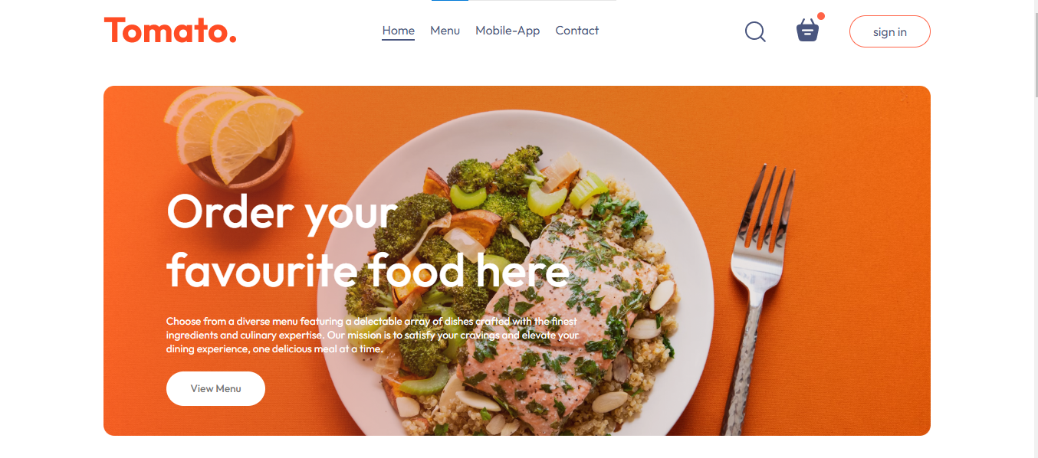

* **Menu (Context area):**

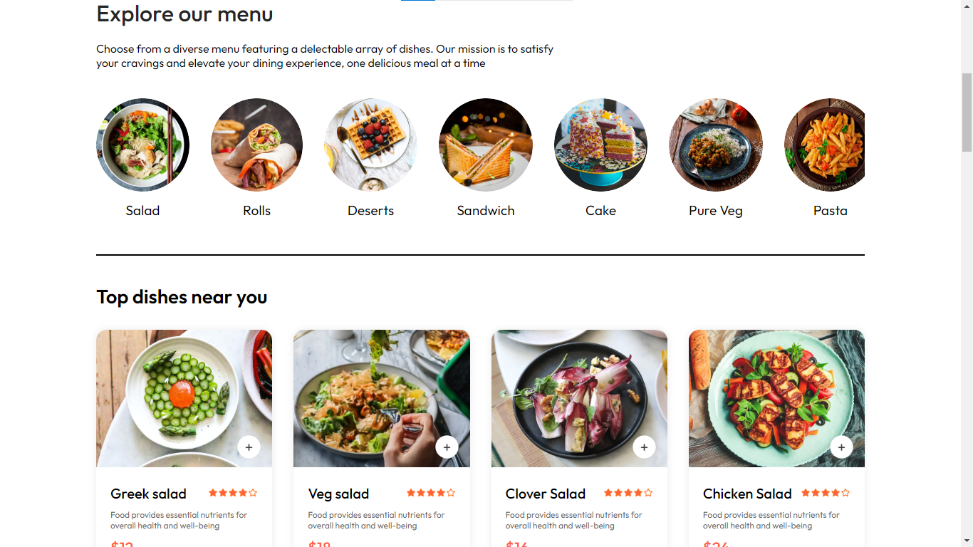

* **App Download Options:**



* **Footer:**

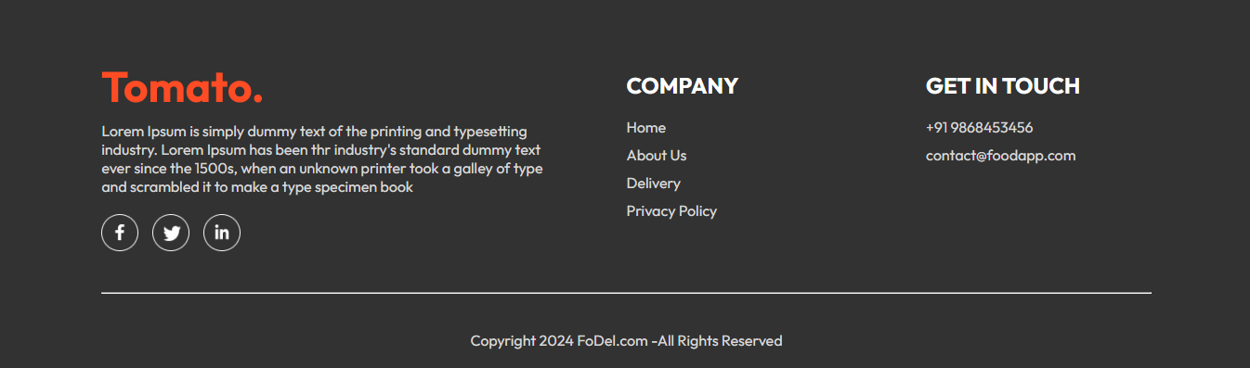

* **Login And Sign Up:**

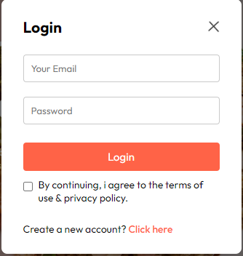 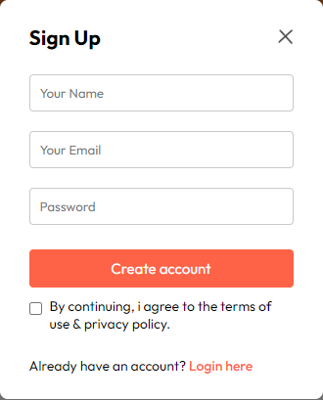

**Cart:**

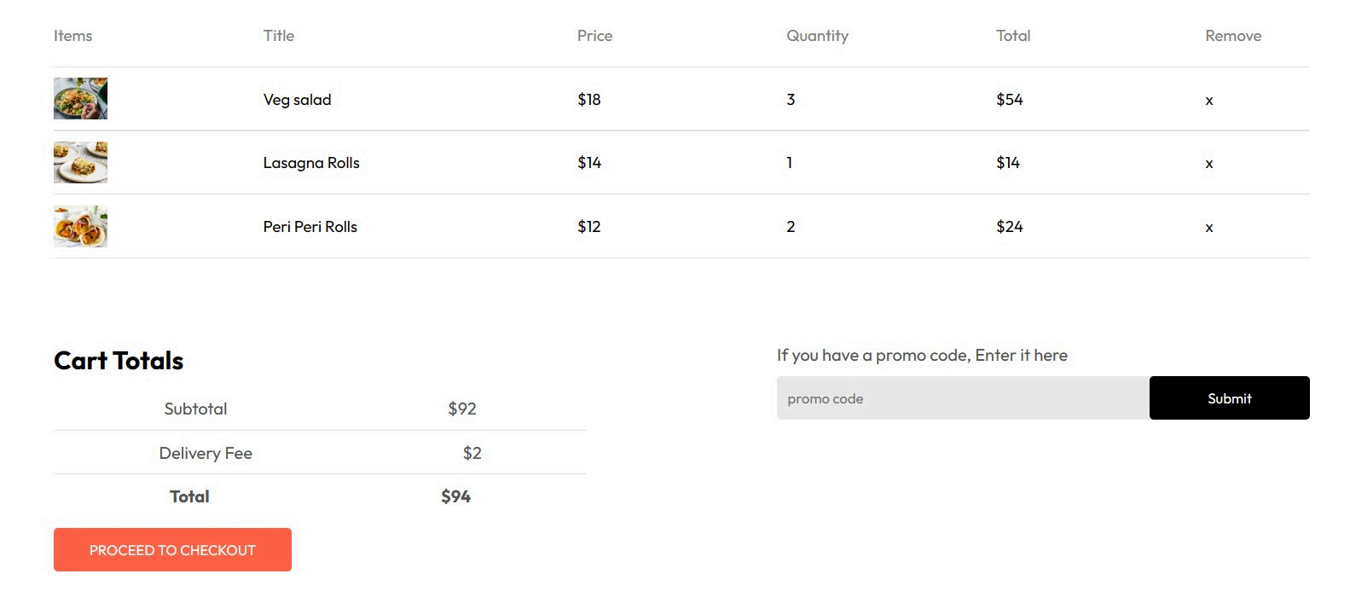

**Customer Details Page:**

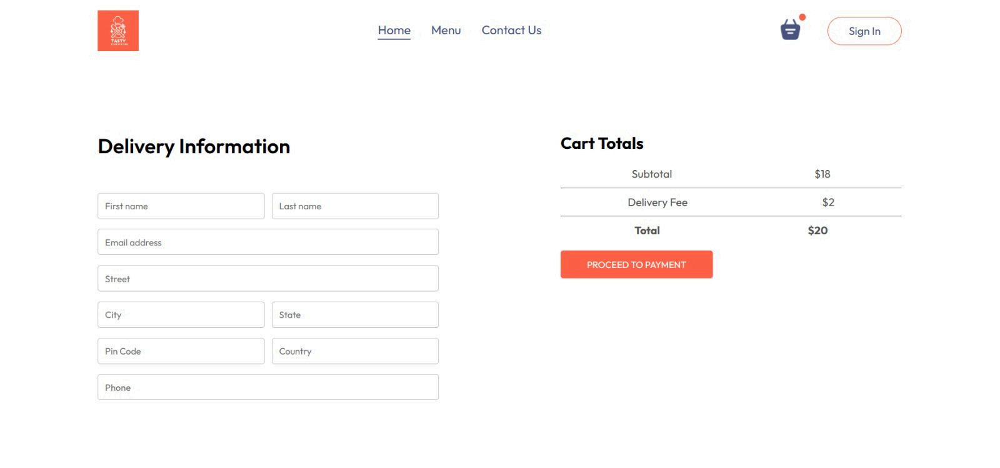

**References:**

* + ChatGpt4
  + Google Fonts
  + Google Images